**LISTENING COMPREHENSION**

**(**[**https://bit.do/av32019**](https://bit.do/av32019)**)**

**TEST 1**

|  |
| --- |
| **LISTENING TEST**  In the Listening test, you will be asked to demonstrate how well you understand spoken English. The entire Listening test will last approximately 45 minutes. There are four parts, and directions are given for each part. You must mark your answers on the separate answer sheet. Do not write your answers in your test book.  **PART 1**  **Directions:** For each question in this part, you will hear four statements about a picture in your test book. When you hear the statements, you must select the one statement that best describes what you see in the picture. Then find the number of the question on your answer sheet and mark your answer. The statements will not be printed in your test book and will be spoken only one time.    Statement (C), “They’re sitting at a table,” is the best description of the picture, so you should select answer (C) and mark it on your answer sheet. |

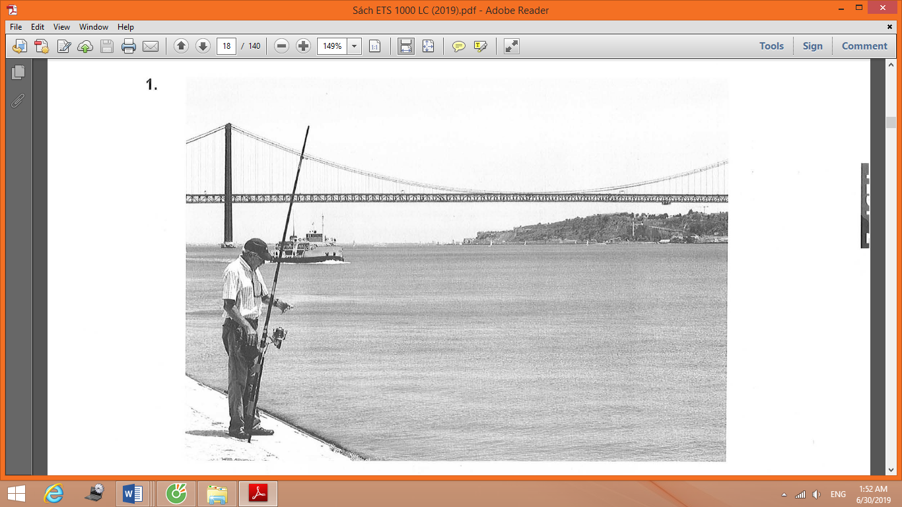

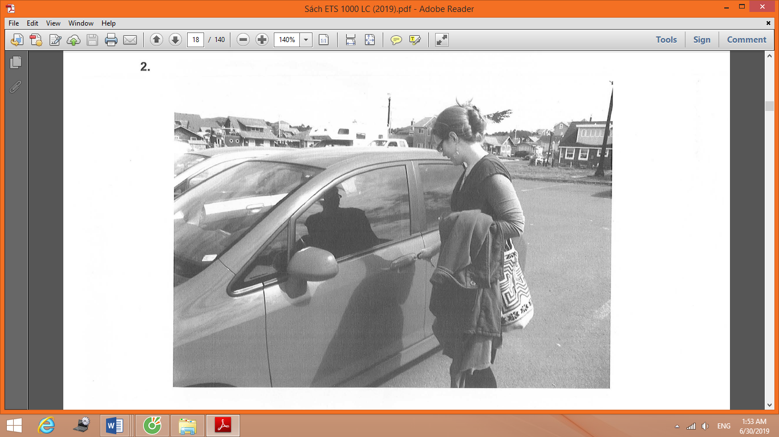

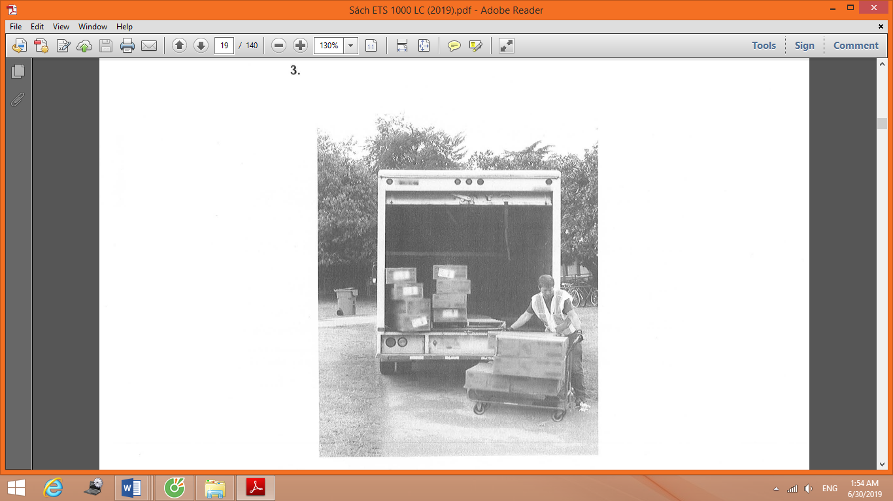

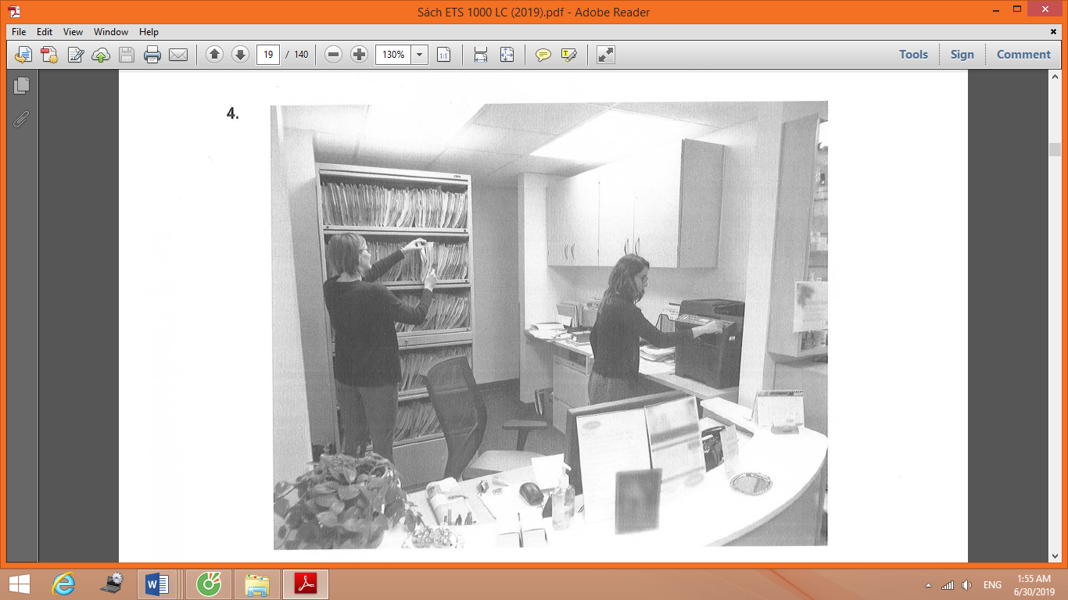

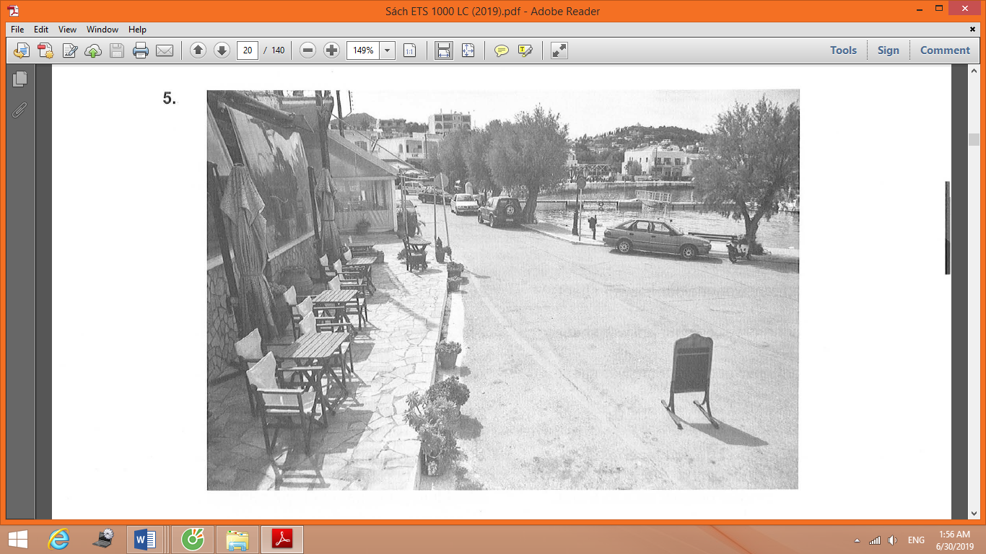

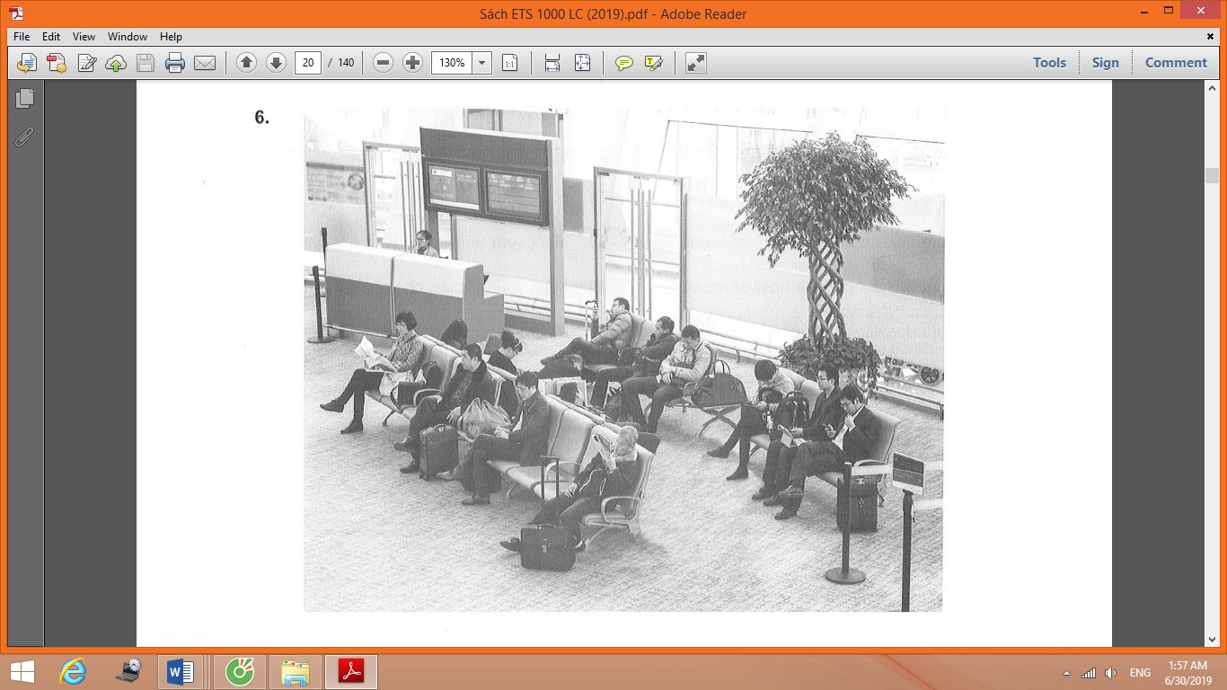

|  |
| --- |
| **PART 2**  **Directions:** You will hear a question or statement and three responses spoken in English. They will not be printed in your test book and will be spoken only one time. Select the best response to the question or statement and mark the letter (A), (B), or (C) on your answer sheet. |

**7.** Mark your answer on your answer sheet. **20.** Mark your answer on your answer sheet.

**8.** Mark your answer on your answer sheet. **21.** Mark your answer on your answer sheet.

**9.** Mark your answer on your answer sheet. **22.** Mark your answer on your answer sheet.

**10.** Mark your answer on your answer sheet. **23.** Mark your answer on your answer sheet.

**11.** Mark your answer on your answer sheet. **24.** Mark your answer on your answer sheet.

**12.** Mark your answer on your answer sheet. **25.** Mark your answer on your answer sheet.

**13.** Mark your answer on your answer sheet. **26.** Mark your answer on your answer sheet.

**14.** Mark your answer on your answer sheet. **27.** Mark your answer on your answer sheet.

**15.** Mark your answer on your answer sheet. **28.** Mark your answer on your answer sheet.

**16.** Mark your answer on your answer sheet. **29.** Mark your answer on your answer sheet.

**17.** Mark your answer on your answer sheet. **30.** Mark your answer on your answer sheet.

**18.** Mark your answer on your answer sheet. **31.** Mark your answer on your answer sheet.

**19.** Mark your answer on your answer sheet.

|  |
| --- |
| **PART 3**  **Directions:** You will hear some conversations between two or more people. You will be asked to answer three questions about what the speakers say in each conversation . Select the best response to each question and mark the letter (A), (B), (C), or (D) on your answer sheet. The conversations will not be printed in your test book and will be spoken only one time. |

**32.** What is the main topic of the conversation?

(A) A new supervisor

(B) A budget report

(C) An office floor plan

(D) A project deadline

**33.** What does the man request?

(A) Additional office supplies

(B) Extra team members

(C) A different office

(D) A sample document

**34.** What does the woman suggest the man do?

(A) Speak with a colleague

(B) Organize some files

(C) Revise a manual

(D) E-mail a memo

**_______________________________**

**35.** Who most likely is the woman?

(A) A journalist

(B) A musician

(C) A theater director

(D) A costume designer

**36.** What does the woman ask about?

(A) A performance

(B) A guest list

(C) Some seating assignments

(D) Some lighting

**37.** What does the man say he would prefer to do?

(A) Complete a task at a later time

(B) Ask for a meal to be delivered

(C) Speak with a manager

(D) Conduct some background research

**_______________________________**

**38.** What is the problem?

(A) There is a scheduling conflict.

(B) There are no projectors available.

(C) A contract is incorrect.

(D) A deadline has been missed.

**39.** What does the woman inquire about?

(A) Comparing competitors’ prices

(B) Purchasing new software

(C) Postponing a training session

(D) Arranging a teleconference

**40.** What does the man say he will do?

(A) Send some materials

(B) Find some supplies

(C) Speak with a supervisor

(D) Contact a client

**_______________________________**

**41.** Where most likely are the speakers?

(A) At a medical office

(B) At a bank

(C) At an electronics store

(D) At a library

**42.** According to the woman, why should Mr. Patel open an account?

(A) To view a presentation

(B) To make an appointment

(C) To receive a free gift

(D) To leave some feedback

**43.** What does Colin give to Mr. Patel?

(A) An application

(B) A receipt

(C) A registration card

(D) A set of instruction

**___________________________**

**44.** What does the man say will take place in two weeks?

(A) An awards ceremony

(B) A staff retreat

(C) A grand opening celebration

(D) A professional conference

**45.** What does the woman say she is concerned about?

(A) An inconvenient location

(B) A missed deadline

(C) A parking fee

(D) A canceled flight

**46.** Why does the man say, “it’s twenty dollars to take a taxi”?

(A) To make a suggestion

(B) To express surprise

(C) To complain about a price

(D) To correct a mistake

**_______________________________**

**47.** Where do the speakers most likely work?

(A) At a local hotel

(B) At an employment agency

(C) At a clothing manufacturer

(D) At a laundry service

**48.** What problem does the man mention?

(A) A machine is broken.

(B) A deadline is not realistic.

(C) An item is poorly made.

(D) A supplier went out of business.

**49.** How will the speakers solve the problem?

(A) By hiring additional staff

(B) By purchasing more material

(C) By updating some machinery

(D) By negotiating with a business

**_______________________________**

**50.** What has the woman forgotten to bring?

(A) A receipt for an item

(B) A loyalty card

(C) Some coupons

(D) Some shopping bags

**51.** What problem does the man mention?

(A) A manager is not available.

(B) A product is out of stock.

(C) A computer system is not working.

(D) An advertised price is incorrect.

**52.** What does the man imply when he says, “I know where it belongs”?

(A) He can tell the woman where to find an item.

(B) He will return an item to the correct location.

(C) A supervisor is not available.

(D) An item has been put on the wrong shelf.

**_____________________________**

**53.** Who most likely is the man?

(A) A professional athlete

(B) A store manager

(C) A city official

(D) A television producer

**54.** What are the speakers discussing?

(A) A health and fitness show

(B) A workplace volunteer event

(C) A road-repair initiative

(D) A bicycle-sharing program

**55.** What does the woman say is part of the service her company provides?

(A) Wellness screening

(B) Local advertising

(C) Product samples

(D) Event tickets

**_______________________________**

**56.** What is the woman announcing?

(A) A design has been approved.

(B) Some employees will be promoted.

(C) Some equipment will be installed.

(D) A security inspection will take place soon.

**57.** What is being arranged for next week?

(A) A board meeting

(B) A training session

(C) A company luncheon

(D) A job interview

**58.** What does the woman say she will do?

(A) Confirm a time

(B) Test some software

(C) Visit a facility

(D) Review a proposal

**_______________________________**

**59.** Who most likely is the woman?

(A) A journalist

(B) A mechanic

(C) An engineer

(D) A plant supervisor

**60.** What is the main topic of the conversation?

(A) New car designs

(B) The opening of a factory

(C) An increase in costs

(D) Safety ratings

**61.** According to the man, what will happen in December?

(A) Discounted trips will be available.

(B) An advertising campaign will start.

(C) An article will be published.

(D) Production will begin at a facility.

**_______________________________**

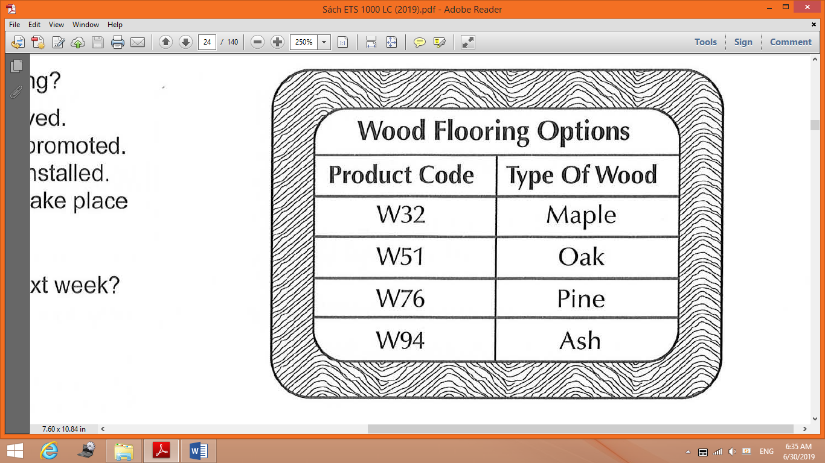

**62.** How did the woman reach her decision?

(A) She did some Internet research.

(B) She asked a friend for a recommendation.

(C) She examined some samples.

(D) She compared prices.

**63.** Look at the graphic. Which product did the woman choose?

(A) W32

(B) W51

(C) W76

(D) W94

**64.** Why does the man need to call back later?

(A) He is unsure about some inventory.

(B) He is about to attend a meeting.

(C) He needs to check his work schedule.

(D) He wants to consult a coworker.

**_______________________________**

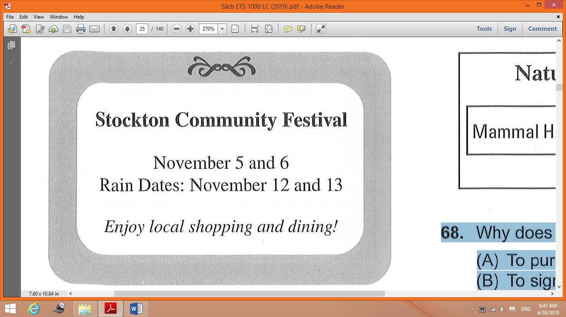

**65.** Who most likely are the speakers?

(A) Community organizers

(B) Weather reporters

(C) Jewelry designers

(D) Restaurant staff

**66.** Look at the graphic. When will the man work at the festival?

(A) On November 5

(B) On November 6

(C) On November 12

(D) On November 13

**67.** What does the woman say she will do?

(A) Hang up some posters

(B) Assist a friend

(C) Prepare some food

(D) Write a review

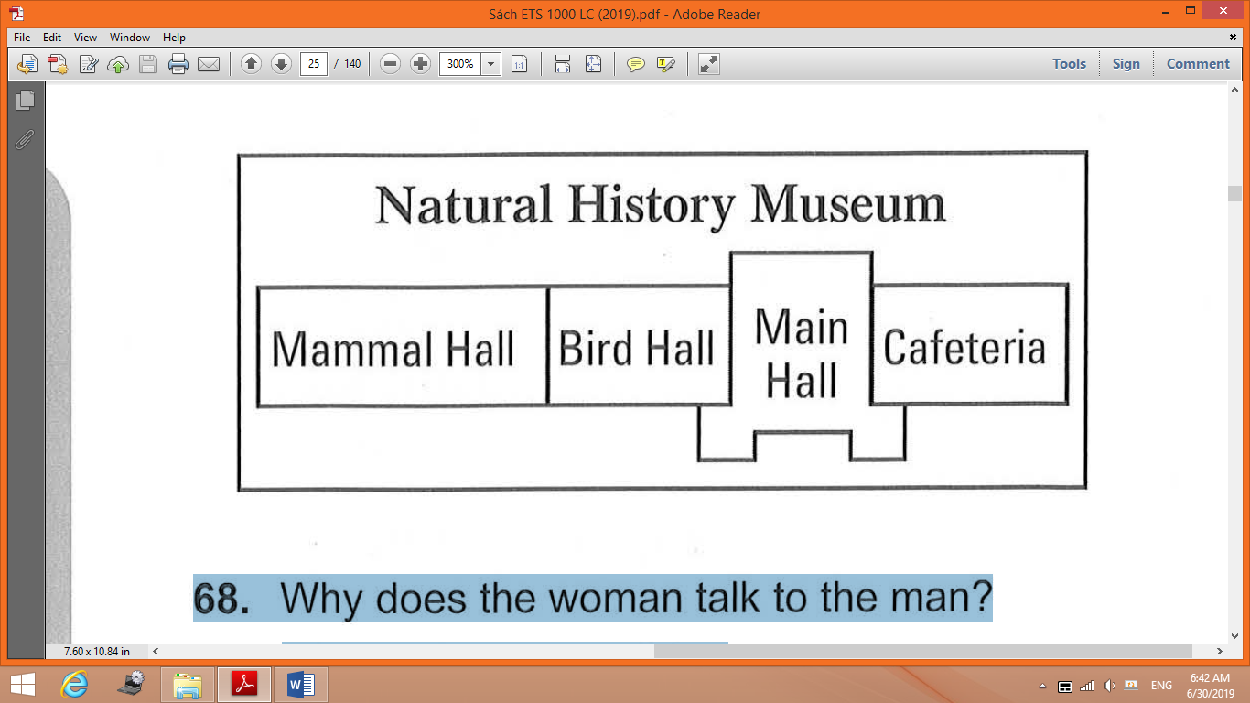

**68.** Why does the woman talk to the man?

(A) To purchase a ticket

(B) To sign up for a tour

(C) To rent some equipment

(D) To inquire about an exhibit

**69.** Look at the graphic. Where does the man tell the woman to go?

(A) To the Mammal Hall

(B) To the Bird Hall

(C) To the Main Hall

(D) To the Cafeteria

**70.** What does the man say about the woman’s ticket?

(A) It can be purchased in advance.

(B) It includes admission to special events.

(C) It is issued only to museum members.

(D) It is nonrefundable.

**_____________________________**

**_______________________________**

|  |
| --- |
| **PART 4**  **Directions:** You will hear some talks given by a single speaker. You will be asked to answer three questions about what the speaker says in each talk. Select the best response to each question and mark the letter (A), (B), (C), or (D) on your answer sheet. The talks will not be printed in your test book and will be spoken only one time. |

**71.** Where is the announcement being made?

(A) At an art supply store

(B) At a public library

(C) At a school

(D) At a hardware store

**72.** What can listeners find on the first floor?

(A) A product demonstration

(B) A discussion-group meeting

(C) Refreshments

(D) Items on sale

**73.** What are listeners encouraged to do by August 30?

(A) Activate a rewards card

(B) Enter a contest

(C) Register for a class

(D) Fill out surveys

**_______________________________**

**74.** Who most likely is the speaker?

(A) An appliance salesperson

(B) A repair technician

(C) An apartment manager

(D) A hotel receptionist

**75.** What is the speaker calling about?

(A) An advertised rebate

(B) An expired warranty

(C) An inaccessible parking space

(D) A broken appliance

**76.** Why is the listener asked to stop by an office?

(A) To return a key

(B) To collect a package

(C) To drop off a letter

(D) To make a payment

**_______________________________**

**77.** What product is the speaker discussing?

(A) A tablet computer

(B) A mobile phone

(C) A radio

(D) A clock

**78.** What is unique about the product?

(A) Its screen

(B) Its low price

(C) Its range of options

(D) Its size

**79.** What does the speaker suggest some listeners do?

(A) Call a customer service number

(B) Recycle older products

(C) Visit a sales booth

(D) Log on to a Web site

**_______________________________**

**80.** Why has the meeting been called?

(A) To explain a manufacturing process

(B) To announce a merger

(C) To provide details on a contract

(D) To inform employees of an error

**81.** Why does the speaker say, “It’s been a week”?

(A) To express concern about a delay

(B) To praise a team’s performance

(C) To remind employees about a rule

(D) To agree with a business strategy

**82.** What does the speaker ask Masaki to do?

(A) Call a shipping company

(B) Verify some addresses

(C) E-mail staff members

(D) Give a speech

**_______________________________**

**83.** Which department does the speaker work for?

(A) Building Security

(B) Public Relations

(C) Technology

(D) Payroll

**84.** What does the speaker ask the listener to do?

(A) Train her on some software

(B) Send an employee to her office

(C) Check some payment information

(D) Attend an orientation

**85.** What does the speaker mean when she says, “This form is only one page, though”?

(A) A policy has been changed.

(B) A task should not take long.

(C) The wrong document was given out.

(D) Some instructions are unclear.

**_______________________________**

**86.** What product will listeners learn about on the tour?

(A) Watches

(B) Computers

(C) Knives

(D) Batteries

**87.** Who is Laura Shen?

(A) A company president

(B) A news journalist

(C) A scientist

(D) A client

**88.** What does the speaker mention about the tour?

(A) Large bags are not allowed.

(B) Photography is not permitted.

(C) The size of a group is limited.

(D) Registration is required.

**_______________________________**

**89.** Who most likely is the speaker?

(A) A travel agent

(B) A chef

(C) A farmer

(D) A filmmaker

**90.** What caused a delay?

(A) Equipment problems

(B) Poor weather conditions

(C) Heavy traffic

(D) Lost luggage

**91.** Why does the speaker say, “I’ll be answering questions when it’s over”?

(A) To explain that he will be busy

(B) To ask listeners not to interrupt him now

(C) To encourage people to stay afterward

(D) To correct a scheduling mistake

**_______________________________**

**92.** Who is the speaker congratulating?

(A) Executive board members

(B) A new business partner

(C) Marketing staff

(D) Food scientists

**93.** According to the speaker, what do customers like about the commercial?

(A) The images of families

(B) The video quality

(C) The professional actors

(D) The background music

**94.** What most likely will listeners do next week?

(A) Interview candidates

(B) Share ideas

(C) Check some statistics

(D) Develop a recipe

**_______________________________**

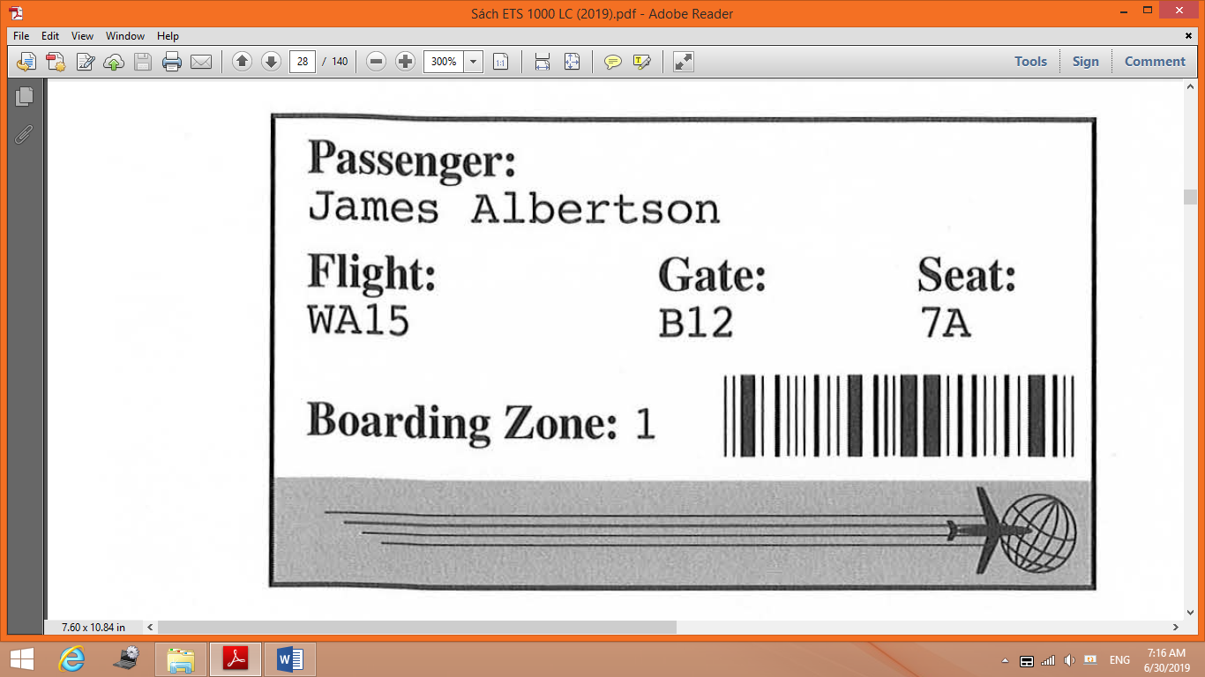

**95.** What is the announcement about?

(A) Connecting flight information

(B) A lost item

(C) A flight cancellation

(D) A gate change

**96.** Look at the graphic. Which number should James Albertson pay attention to now?

(A) WA15

(B) B12

(C) 7A

(D) 1

**97.** What will the speaker announce later?

(A) Where to find luggage

(B) How to select a new seat

(C) Whom to contact for a refund

(D) When repairs will be finished

**_______________________________**

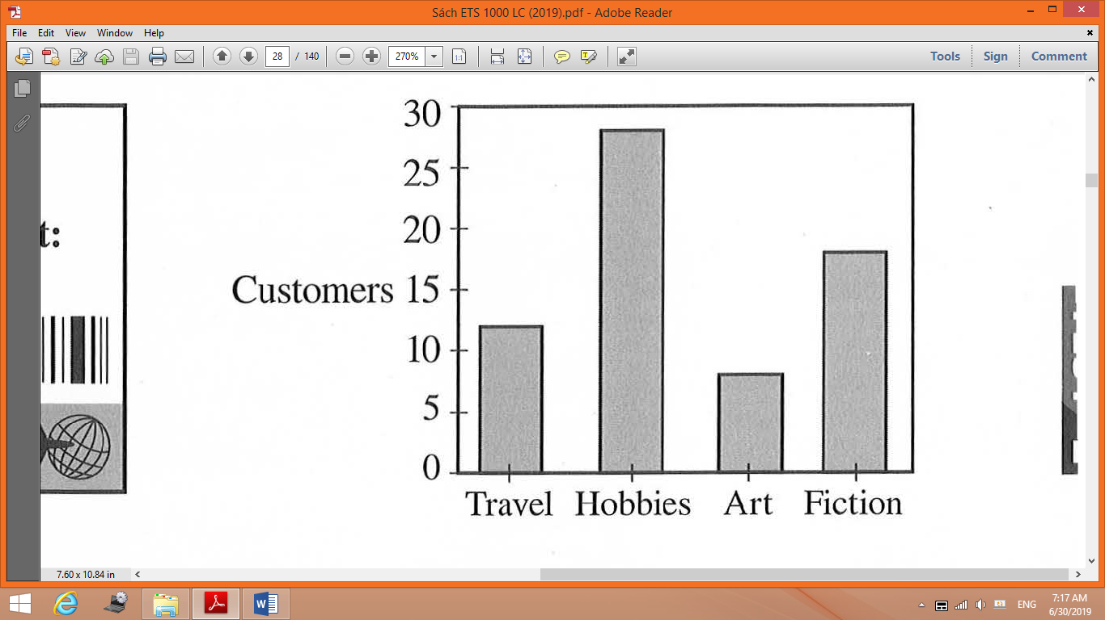

**98.** What event did the speaker recently attend?

(A) An advertising seminar

(B) An awards ceremony

(C) A managers’ meeting

(D) A writing workshop

**99.** What topic does the speaker report on?

(A) Company finances

(B) Human resources

(C) Advertising

(D) Competitors

**100.** Look at the graphic. Which store section will be expanded?

(A) Travel

(B) Hobbies

(C) Art

(D) Fiction

**_______________________________**

**This is the end of the Listening test.**

**TEST 2**

|  |
| --- |
| **LISTENING TEST**  In the Listening test, you will be asked to demonstrate how well you understand spoken English. The entire Listening test will last approximately 45 minutes. There are four parts, and directions are given for each part. You must mark your answers on the separate answer sheet. Do not write your answers in your test book.  **PART 1**  **Directions:** For each question in this part, you will hear four statements about a picture in your test book. When you hear the statements, you must select the one statement that best describes what you see in the picture. Then find the number of the question on your answer sheet and mark your answer. The statements will not be printed in your test book and will be spoken only one time.    Statement (C), “They’re sitting at a table,” is the best description of the picture, so you should select answer (C) and mark it on your answer sheet. |

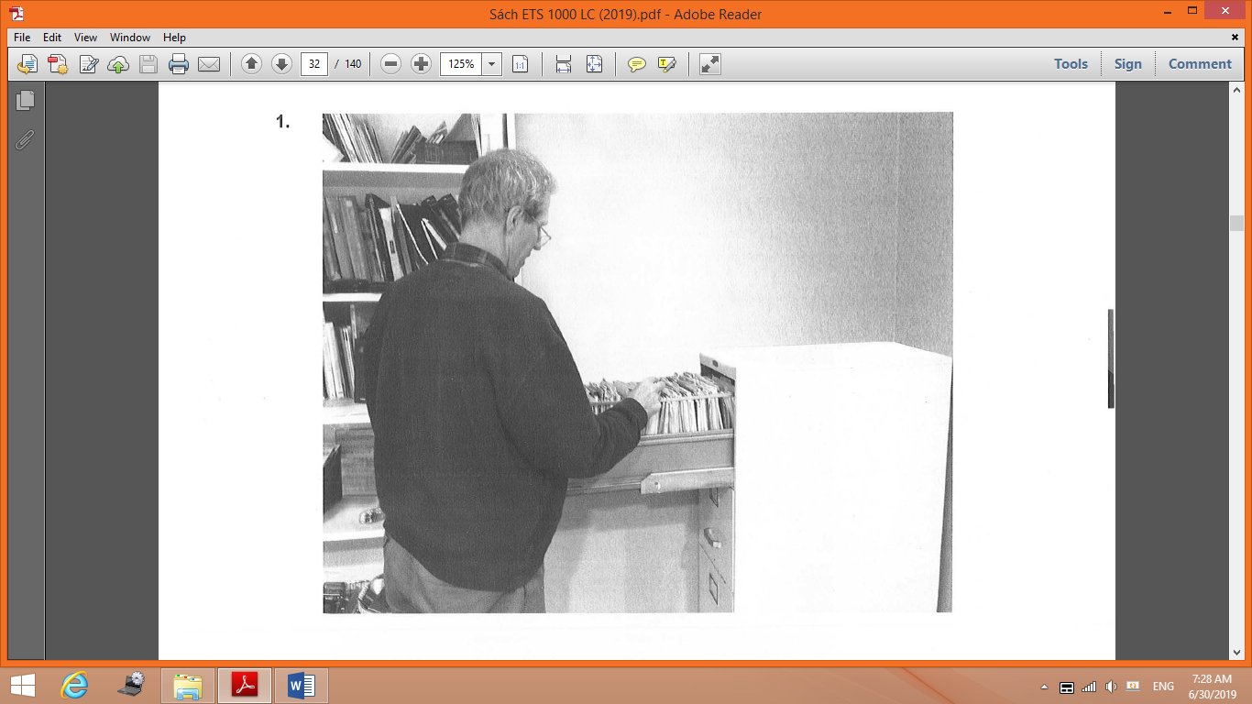

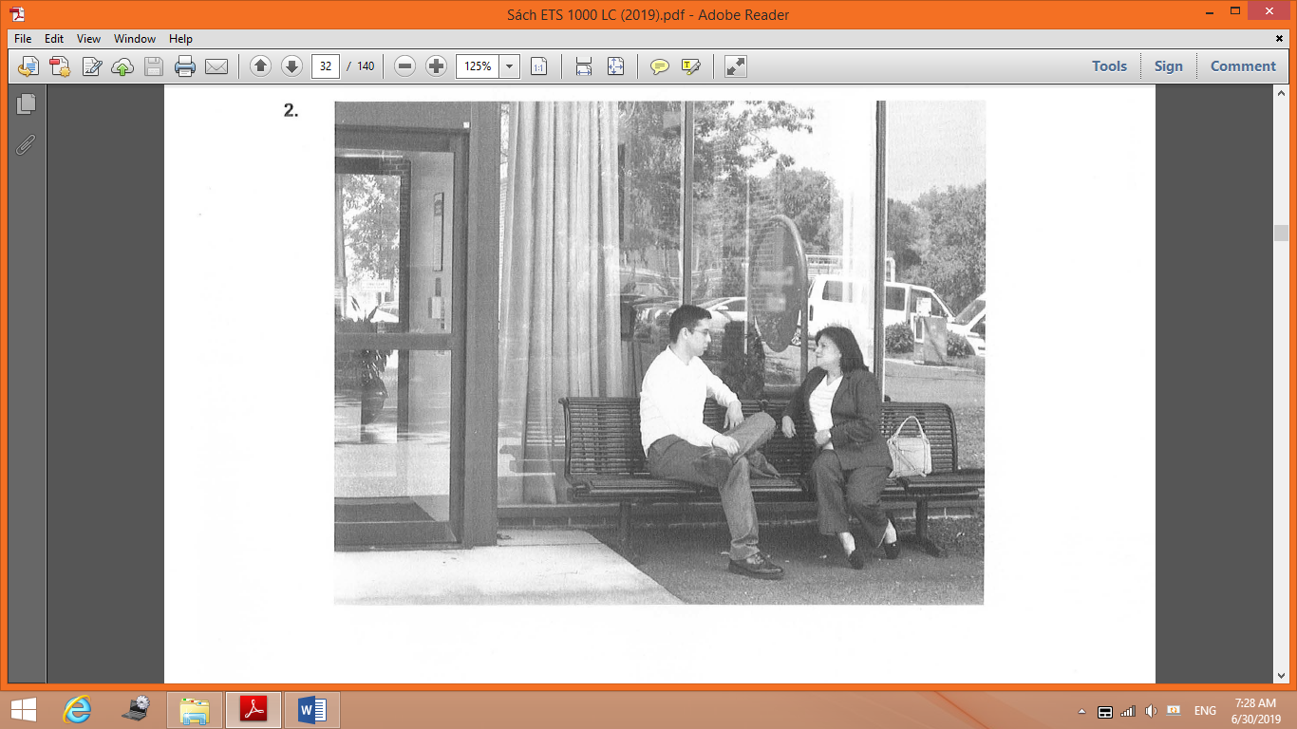

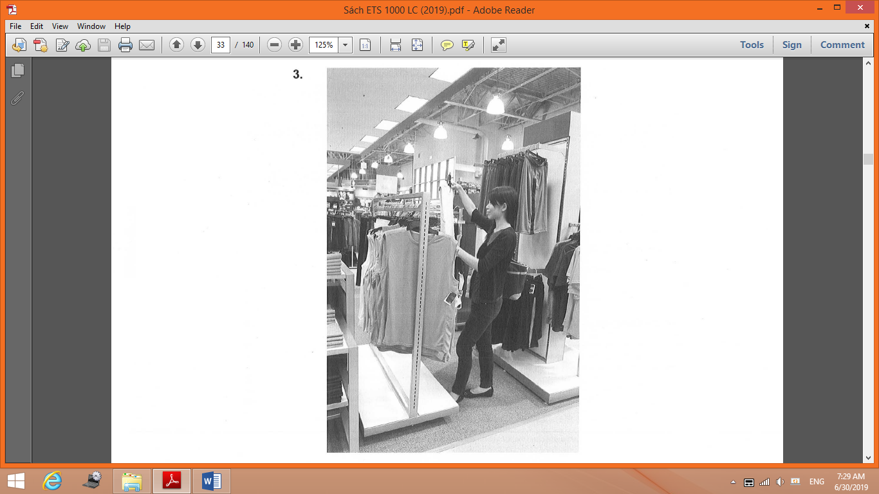

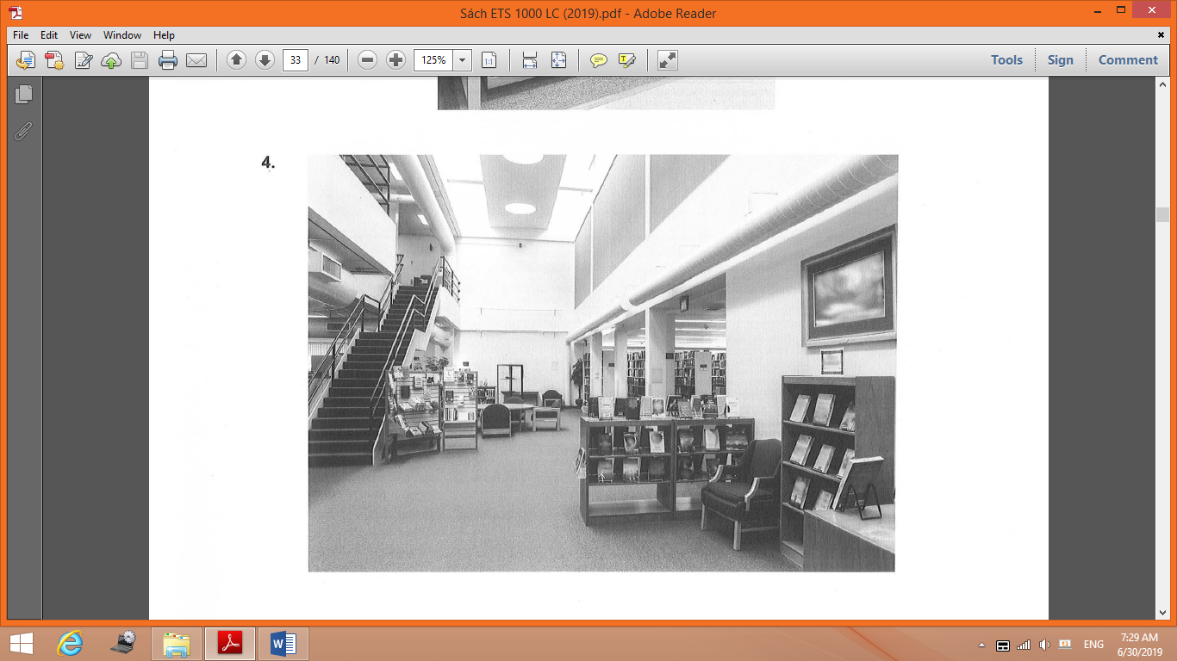

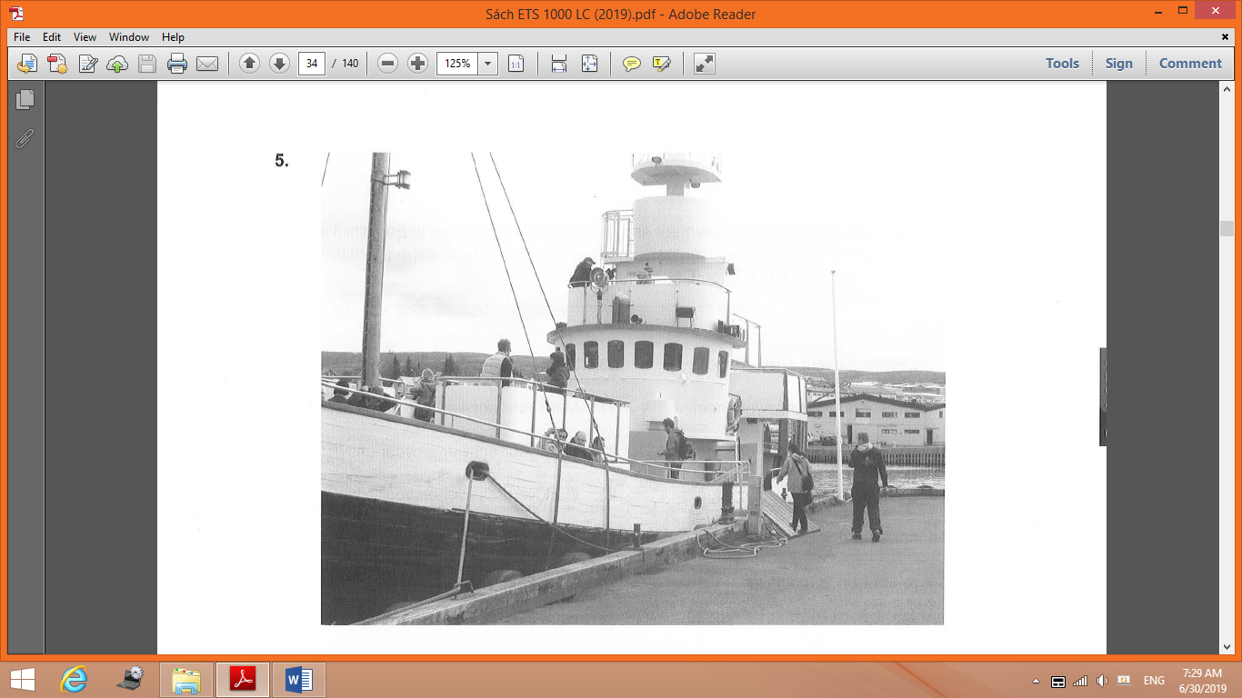

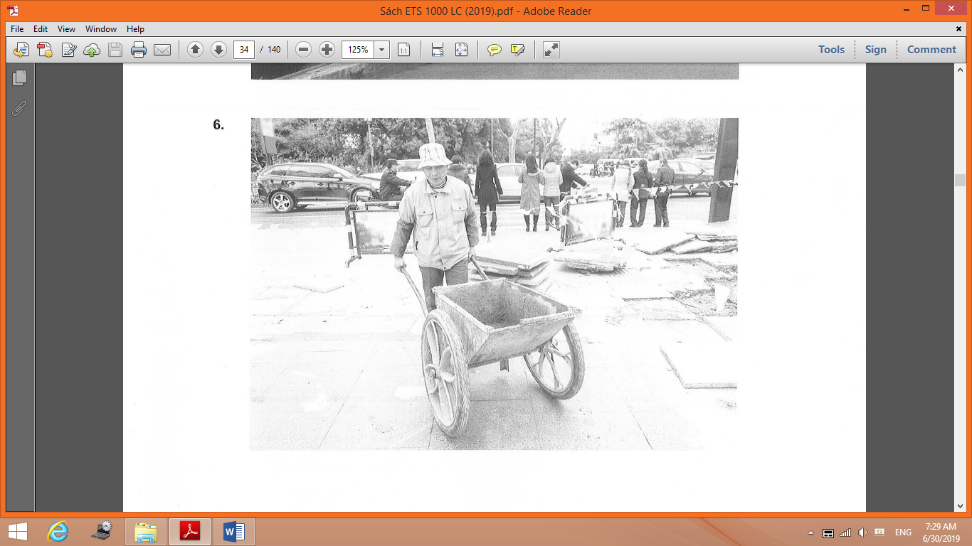

|  |
| --- |
| **PART 2**  **Directions:** You will hear a question or statement and three responses spoken in English. They will not be printed in your test book and will be spoken only one time. Select the best response to the question or statement and mark the letter (A), (B), or (C) on your answer sheet. |

**7.** Mark your answer on your answer sheet. **20.** Mark your answer on your answer sheet.

**8.** Mark your answer on your answer sheet. **21.** Mark your answer on your answer sheet.

**9.** Mark your answer on your answer sheet. **22.** Mark your answer on your answer sheet.

**10.** Mark your answer on your answer sheet. **23.** Mark your answer on your answer sheet.

**11.** Mark your answer on your answer sheet. **24.** Mark your answer on your answer sheet.

**12.** Mark your answer on your answer sheet. **25.** Mark your answer on your answer sheet.

**13.** Mark your answer on your answer sheet. **26.** Mark your answer on your answer sheet.

**14.** Mark your answer on your answer sheet. **27.** Mark your answer on your answer sheet.

**15.** Mark your answer on your answer sheet. **28.** Mark your answer on your answer sheet.

**16.** Mark your answer on your answer sheet. **29.** Mark your answer on your answer sheet.

**17.** Mark your answer on your answer sheet. **30.** Mark your answer on your answer sheet.

**18.** Mark your answer on your answer sheet. **31.** Mark your answer on your answer sheet.

**19.** Mark your answer on your answer sheet.

|  |
| --- |
| **PART 3**  **Directions:** You will hear some conversations between two or more people. You will be asked to answer three questions about what the speakers say in each conversation . Select the best response to each question and mark the letter (A), (B), (C), or (D) on your answer sheet. The conversations will not be printed in your test book and will be spoken only one time. |

**32.** What does the company most likely produce?

(A) Print advertisements

(B) Television shows

(C) Computer parts

(D) Musical instruments

**33.** What department will the man work in?

(A) Accounting

(B) Legal

(C) Human resources

(D) Security

**34.** What does the man like about his work area?

(A) It is conveniently located.

(B) It has a good view.

(C) It is quiet.

(D) It is nicely decorated.

**_______________________________**

**35.** What is the conversation mainly about?

(A) A room reservation

(B) A canceled event

(C) A restaurant recommendation

(D) A misplaced item

**36.** What does the man need to provide?

(A) A security deposit

(B) A revised schedule

(C) A form of identification

(D) A business address

**37.** What do the visitors ask for?

(A) A refund

(B) Better lighting

(C) Menu options

(D) More chairs

**_______________________________**

**38.** Where does the conversation most likely take place?

(A) At a shopping mall

(B) At a theater

(C) In a sports stadium

(D) On a train

**39.** Why does the woman say, “The football championship is this afternoon”?

(A) To extend an invitation

(B) To offer encouragement

(C) To give an explanation

(D) To request a schedule change

**40.** What does the man say he needs to purchase?

(A) Tickets

(B) Clothes

(C) Food

(D) Furniture

**___________________________**

**41.** What problem does the man mention?

(A) Some products are damaged.

(B) Some equipment is out of stock.

(C) A vehicle has broken down.

(D) A delivery error has occurred.

**42.** What does the woman say is planned for Friday?

(A) A product launch

(B) An inspection

(C) A cooking class

(D) An interview

**43.** What does the man say he will do?

(A) Transfer a call

(B) Issue a refund

(C) Provide a warranty

(D) Visit a business

**_________________________**

**44.** Where do the speakers most likely work?

(A) At a law office

(B) At a supermarket

(C) At a medical clinic

(D) At a recreation center

**45.** What are the speakers mainly discussing?

(A) A marketing campaign

(B) A new product

(C) Some budget cuts

(D) Some survey results

**46.** What does the woman imply when she says, “That would require significant revisions to our scheduling process”?

(A) She doubts a change will be implemented.

(B) She thinks more staff should be hired.

(C) She needs more time to make a decision.

(D) She believes some data is incorrect.

**_______________________________**

**47.** Why did the woman miss a meeting?

(A) She was not feeling well.

(B) She was on a business trip.

(C) She was speaking with a client.

(D) She did not receive the invitation.

**48.** What is the woman confused about?

(A) The details of an assignment

(B) A reimbursement process

(C) The terms of a contract

(D) A travel itinerary

**49.** According to the man, what should the woman do?

(A) Reset the password for her computer

(B) Talk to the organizer of the meeting

(C) Consult the electronic version of a document

(D) Research the history of an account

**_______________________________**

**50.** What is the woman an expert in?

(A) Gardening

(B) Nutrition

(C) Appliance repair

(D) Fitness training

**51.** What does the woman recommend?

(A) Substituting ingredients

(B) Using appropriate tools

(C) Changing an exercise routine

(D) Scheduling regular maintenance

**52.** According to the woman, where can listeners find more information?

(A) On a television show

(B) On a Web site

(C) In a magazine

(D) In a book

**_______________________________**

**53.** What does the woman say about the man’s job performance?

(A) He is respected by his colleagues.

(B) He always meets his deadlines.

(C) He has good ideas for new projects.

(D) He has increased company profits.

**54.** What does the woman ask the man to do?

(A) Attend a trade show

(B) Join a leadership council

(C) Mentor a colleague

(D) Accept a new position

**55.** When will the speakers meet again?

(A) Tomorrow

(B) Next week

(C) Next month

(D) Next quarter

**_______________________________**

**56.** What does the man ask the women about?

(A) The types of projects assigned

(B) The backgrounds of the applicants

(C) The status of training materials

(D) The location of an orientation

**57.** What does the man say about last year’s internship program?

(A) Some new products were developed.

(B) Some information was unclear.

(C) There were not enough supplies.

(D) There were a large number of applicants.

**58.** What does the man say he is pleased about?

(A) The summer schedule

(B) The careful planning

(C) The deadline extension

(D) The approval process

**_______________________________**

**59.** What type of business does the woman work for?

(A) A moving company

(B) A real estate agency

(C) An insurance firm

(D) An equipment rental service

**60.** What is the woman concerned about?

(A) Shipping delays

(B) New regulations

(C) An increase in competition

(D) A shortage of staff

**61.** What does the woman emphasize about her company?

(A) The affordable prices

(B) The number of branch offices

(C) The user-friendly Web site

(D) The customer service

**______________________________**

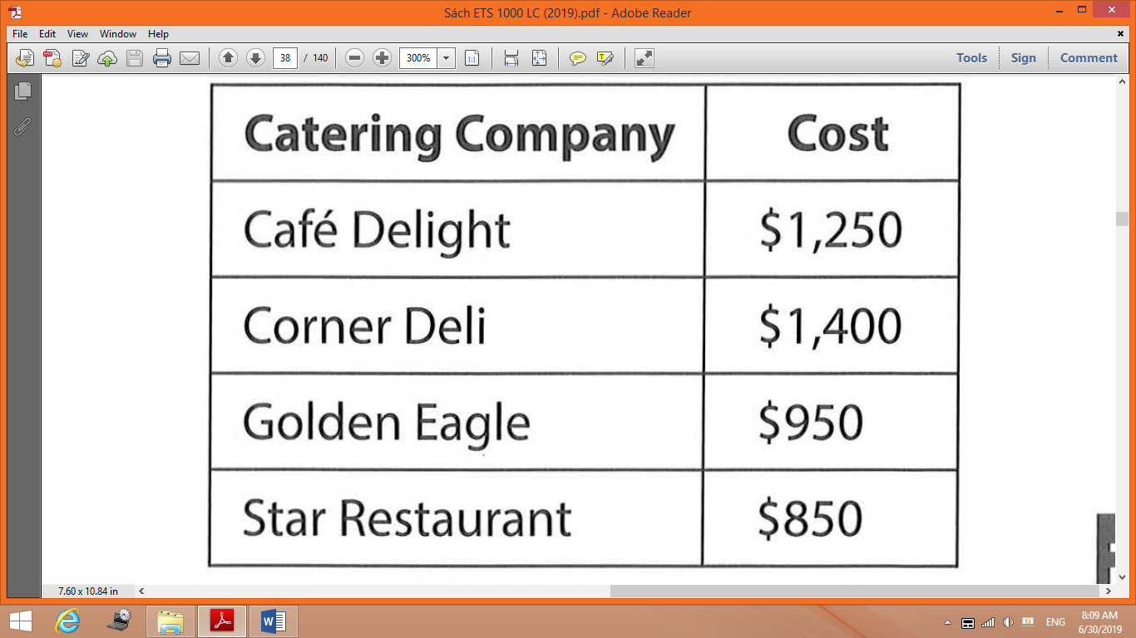

**62.** What type of event are the speakers discussing?

(A) A shareholders’ meeting

(B) A press conference

(C) A job fair

(D) A product demonstration

**63.** What problem did the woman experience with one of the restaurants?

(A) An unhelpful staff member

(B) A poorly cooked meal

(C) A billing error

(D) A delivery delay

**64.** Look at the graphic. How much will the lunch most likely cost?

(A) $1,250

(B) $1,400

(C) $950

(D) $850

**_______________________________**

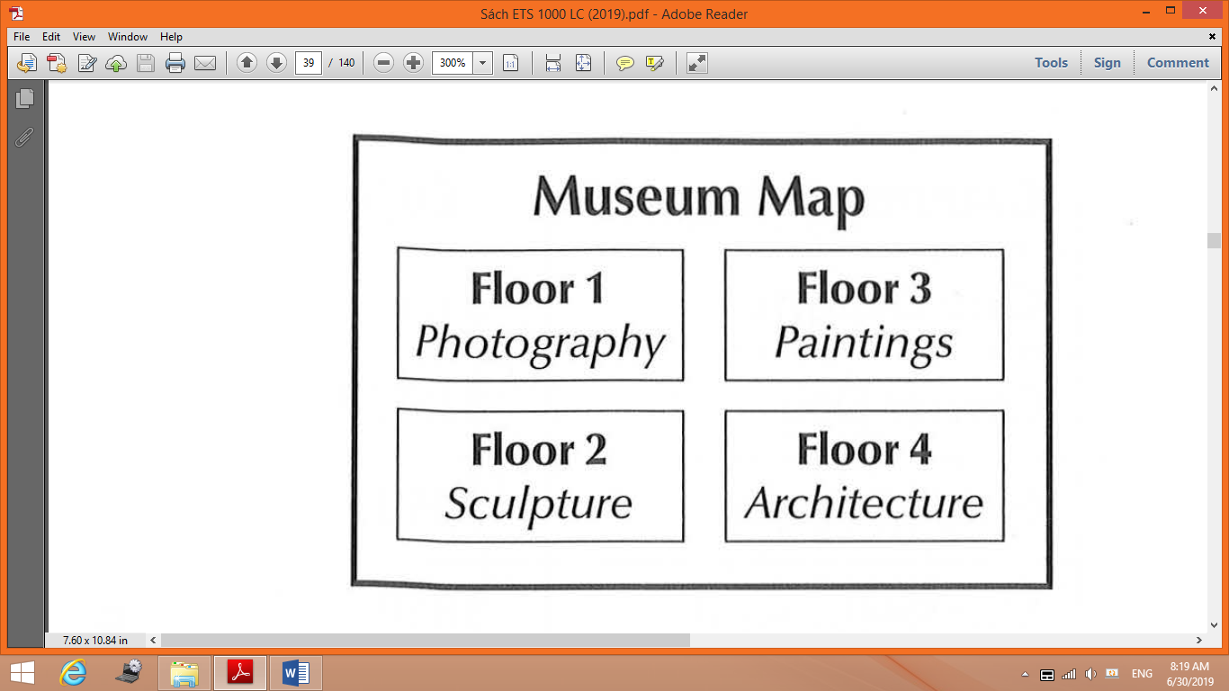

**65.** Look at the graphic. On which floor will the man meet his friends?

(A) Floor 1

(B) Floor 2

(C) Floor 3

(D) Floor 4

**66.** What will happen at the museum this summer?

(A) A workshop will be offered.

(B) A special exhibit will open.

(C) Concerts will be held in the garden.

(D) Some galleries will be renovated .

**67.** Why does the woman suggest using the stairs at the back of the museum?

(A) They are nearby.

(B) They offer a good view.

(C) They were recently added.

(D) They are not crowded.

**_____________________________**

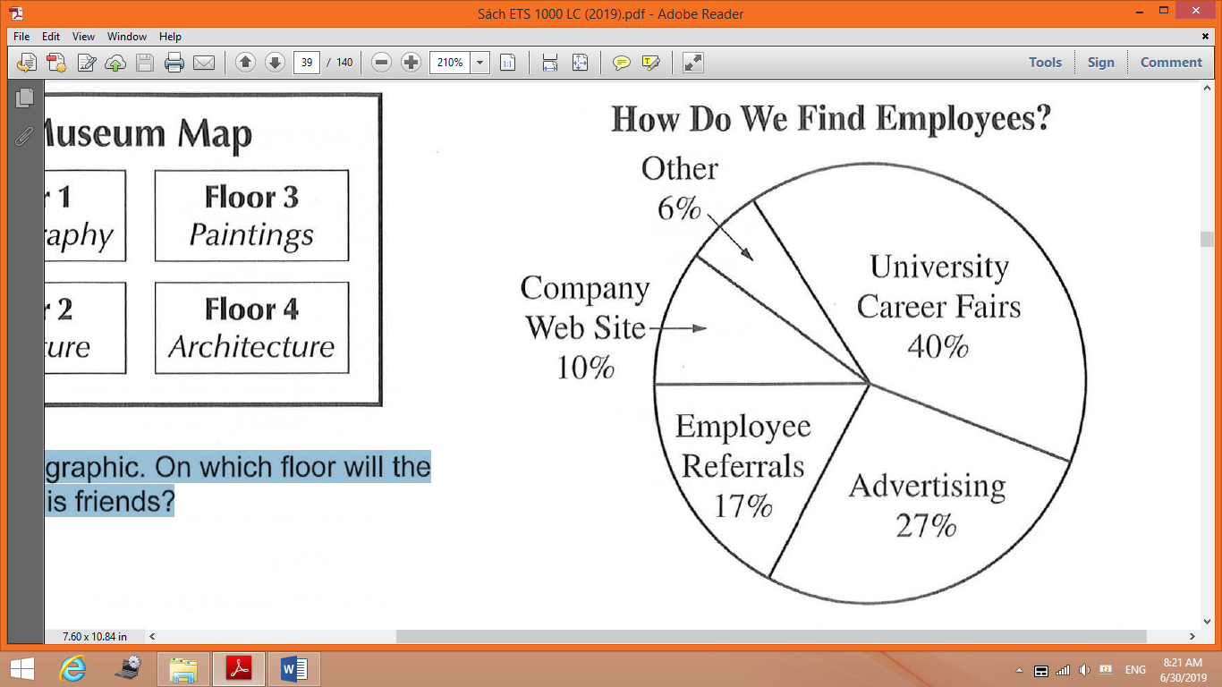

**68.** What does the woman want to do?

(A) Make travel arrangements

(B) Revise a budget

(C) Change recruiting tactics

(D) Give a lecture

**69.** Look at the graphic. Which method does the man suggest using?

(A) University career fairs

(B) Advertising

(C) Employee referrals

(D) Company Web site

**70.** What does the woman suggest the man do?

(A) Design a questionnaire

(B) Renew a contract

(C) Work with a colleague

(D) Interview a job candidate

**_____________________________**

|  |
| --- |
| **PART 4**  **Directions:** You will hear some talks given by a single speaker. You will be asked to answer three questions about what the speaker says in each talk. Select the best response to each question and mark the letter (A), (B), (C), or (D) on your answer sheet. The talks will not be printed in your test book and will be spoken only one time. |

**71.** At which event is the announcement being made?

(A) A book fair

(B) A product launch

(C) A technology conference

(D) A charity fundraiser

**72.** According to the speaker, what can some listeners do tomorrow?

(A) Go on a tour

(B) Attend an opening ceremony

(C) Participate in a focus group

(D) Win a prize

73. What are the listeners instructed to do?

(A) Use an alternate entrance

(B) Register in advance

(C) Complete a survey

(D) Meet at a designated location

**_____________________________**

**74.** What product does Castillo manufacture?

(A) Jewelry

(B) Clothing

(C) Art supplies

(D) Backpacks

**75.** Why does the speaker say, “Just look at the color selection in these samples”?

(A) To introduce a new manufacturing technique

(B) To assign a task

(C) To express disappointment

(D) To support a decision

**76.** What will Hae-Rim do?

(A) Present financial information

(B) Share competitor data

(C) Analyze survey results ·

(D) Introduce advertising layouts

**_______________________________**

**77.** Who most likely is the speaker?

(A) An investment banker

(B) A city official

(C) A food scientist

(D) A restaurant manager

**78.** According to the speaker, what will happen next week?

(A) Some new equipment will be installed.

(B) A corporate office will relocate.

(C) New menu items will be available.

(D) Seasonal employees will begin work.

**79.** What does the speaker warn listeners about?

(A) Preparing orders carefully

(B) Wearing proper attire

(C) Recording hours accurately

(D) Taking inventory daily

**_______________________________**

**80.** Why is the speaker calling?

(A) To register for a training session

(B) To request help with a project

(C) To book a meeting room

(D) To get updated customer information

**81.** What does the speaker imply when she says, “it wasn’t my idea”?

(A) She knows a change is inconvenient.

(B) She thinks a colleague deserves credit.

(C) She would like the listener's opinion.

(D) She is going to explain a new procedure.

**82.** What does the speaker ask the listener to do?

(A) Order business cards

(B) Check a mailbox

(C) Revise a report

(D) Reserve a booth

**_______________________________**

**83.** What will the company do beginning on June 1?

(A) Accept reservations online

(B) Provide service to a new location

(C) Offer a customer loyalty program

(D) Lower its express shipping rates

**84.** According to the speaker, what must customers do in order to ship a vehicle?

(A) Show proof of ownership

(B) Provide an extra set of keys

(C) Purchase additional insurance

(D) Get a mechanical inspection

**85.** What does the speaker indicate about the call?

(A) It will be redirected to a different department.

(B) It will be answered in the order in which it was received.

(C) It may be several minutes until a representative answers.

(D) It may be recorded for future use.

**_______________________________**

**86.** Who is the intended audience for the talk?

(A) Theater patrons

(B) Costume makers

(C) Ticket sellers

(D) Stage musicians

**87.** What does the speaker mention about the play?

(A) It is very long.

(B) It is set in the past.

(C) There are many characters.

(D) There is a waiting list for tickets.

**88.** What will take place in five weeks?

(A) A photography session

(B) A dinner reception

(C) A fashion show

(D) A dress rehearsal

**_______________________________**

**89.** What was the speaker supposed to do this morning?

(A) Interview a job applicant

(B) Attend a meeting

(C) Pick up a client

(D) Lead a tour group

**90.** What transportation problem does the speaker mention?

(A) A road has been closed.

(B) A bridge is under construction.

(C) A train service is unavailable.

(D) A flight has been delayed.

**91.** What does the speaker suggest?

(A) Inviting other colleagues

(B) Posting a notice

(C) Holding a phone conference

(D) Having lunch together

**_______________________________**

**92.** What industry does the speaker work in?

(A) Renewable energy

(B) Computer technology

(C) Publishing

(D) Real estate

**93.** What does the speaker imply when he says, “hundreds of businesses have signed up”?

(A) He is worried about meeting client demands.

(B) He expects an industry to start changing.

(C) The listeners should choose his company.

(D) The listeners will receive a list of contacts.

**94.** What will the listeners see in the video?

(A) A virtual tour

(B) An award-acceptance speech

(C) Product features

(D) Installation instructions

**_______________________________**

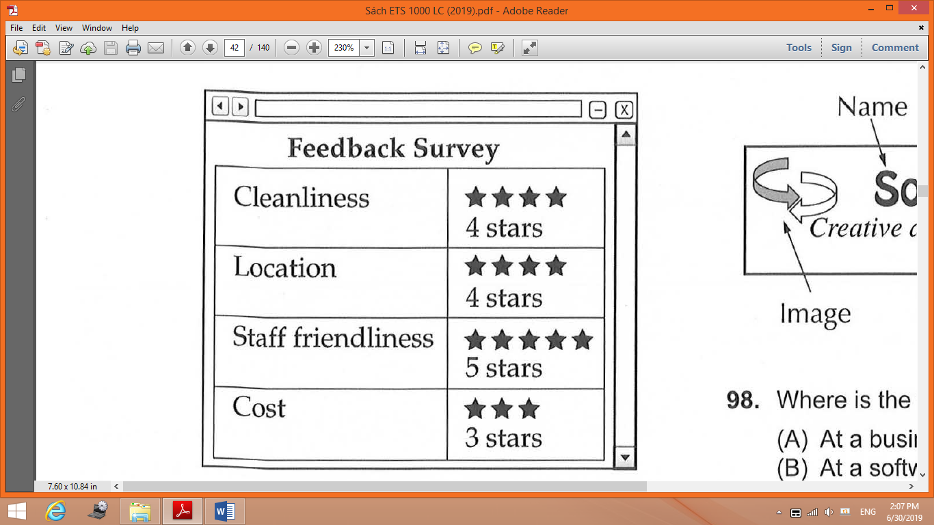

**95.** Who is the message most likely for?

(A) A fitness instructor

(B) A data analyst

(C) A gym member

(D) A marketing expert

**96.** What does the speaker say he has e-mailed the listener?

(A) A discount voucher

(B) Driving directions

(C) A fitness magazine

(D) Class schedules

**97.** Look at the graphic. Which category does the speaker request more information about?

(A) Cleanliness

(B) Location

(C) Staff friendliness

(D) Cost

**_______________________________**

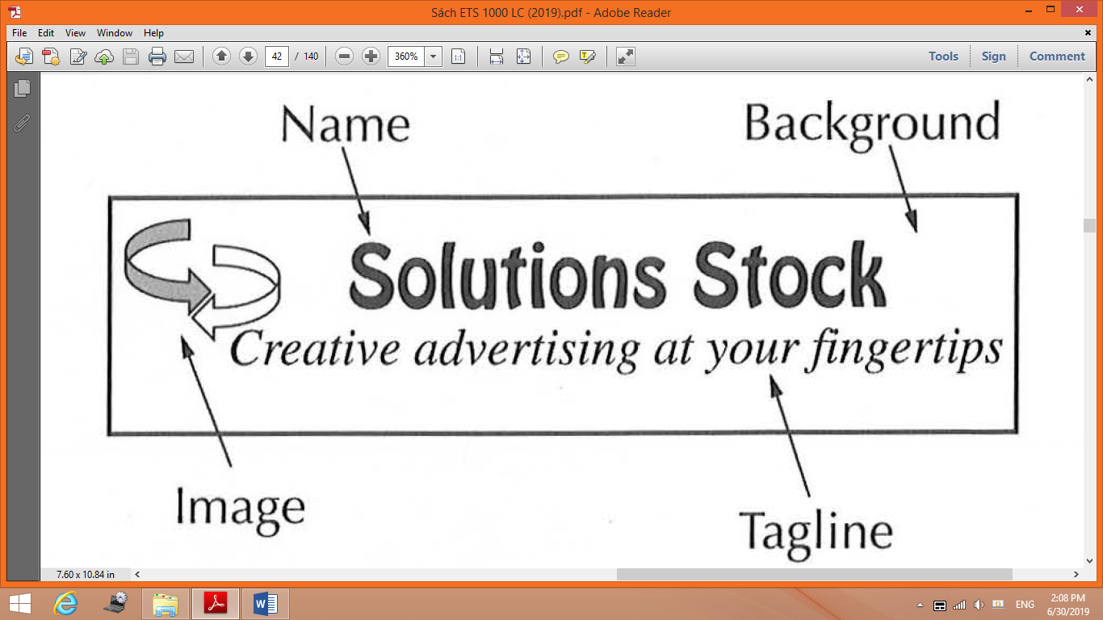

**98.** Where is the talk most likely taking place?

(A) At a business class

(B) At a software training session

(C) At a department meeting

(D) At a client presentation

**99.** Look at the graphic. Which part of the logo does the speaker discuss first?

(A) The name

(B) The background

(C) The image

(D) The tagline

**100.** What will the listeners do next?

(A) Break into small groups

(B) Write down some ideas

(C) Read an article

(D) Check a Web site

**______________________________**

**This is the end of the Listening test.**

**GRAMMAR**

**UNIT 10: SCIENCE**

**(PRESENT PERFECT AND SIMPLE PAST)**

1. Where _____ you last night?

A. were B. was C. is D. are

2. Production levels have _______ been high before.

A. 3 days ago B. never C. yet D. every month

3. I’ve _______ the book already.

A. readed B. read C. reading D. been read

4. ______ she go out last night?

A. Did B. Was C. Is D. Does

5. They went to see a movie, but they _______ enjoy it.

A. don’t B. weren’t C. doesn’t D. didn’t

6. _______ she at home yesterday morning?

A. Was B. Were C. Is D. Does

7. When ________ here?

A. did you arrive B. are you arrive C. do you arriving D. have you arrived

8. I’ve never ________ a horse.

A. ride B. ridden C. rode D. rodden

9. Mike _______ repaired the car.

A. didn’t B. doesn’t C. haven’t D. hasn’t

10. Ms. Griffiths was eliminated as a candidate when she answered *yes* to the question, "Have you ever ________ anything from a previous employer?"

A. stolen B. stealing C. stole D. steal

11. ___________ out last night?

A. Did go you B. Were you do C. Did you go D. You did go

12. I ________ my school-bag yesterday morning.

A. losed B. have lost C. lose D. lost

13. At one time, huge prehistoric reptiles dominated the earth. This Age of Dinosaurs ________ much longer than the present Age of Mammals has lasted to date.

A. has lasted B. was lasting C. lasted D. lasts

14. Only July 20, 1969, Astronaut Neil Armstrong _________ down onto the moon, the first person ever to set foot on another celestial body.

A. was stepping B. steped C. was step D. stepped

15. Susan often __________ her car to school last semester.

A. rode B. drove C. went with D. got off

16. Fish were among the earlier forms of life. Fish ________ on earth for ages and ages.

A. existed B. has existed C. have existed D. exist

17. He has lived here ___________ he was born.

A. before B. after C. for D. since

18. He ____________ on the grass.

A. lay B. laid C. laied D. lied

19. We _______ tired when we got home, so we went to bed.

A. are B. were C. was D. did

20. I _______ anything because I didn’t have any money with me.

A. don’t buy B. am not buy C. didn’t buy D. wasn’t buy

**UNIT 11: TOURISM**

**(SHOULD/SHOULDN’T, HAVE TO/ DON’T HAVE TO, CAN/ CAN’T, EVERYWHERE, NOWHERE, SOMEWHERE, ANYWHERE)**

1. You _______ introduce me to him because we have already met.

A. doesn’t have to B. isn’t have to C. don’t have to D. wasn’t have to

2. She really _______ to learn to control her temper in the office.

A. has B. have C. will D. having

3. I can’t find my mobile phone __________________.

A. anybody B. anywhere C. somewhere D. nowhere

4. Thank goodness we _______ eat fish again tonight. Dad didn’t catch any today.

A. doesn’t have to B. have to C. not have to D. don’t have to

5. I can play the piano, but my brother _________ .

A. isn’t B. doesn’t C. can’t D. didn’t

6. Tom painted his room black. It looks dark and dreary. He ______ have chosen another color.

A. can’t B. should C. shouldn’t D. should to

7. You know, you really should ________ so much. It isn’t good for you.

A. don’t smoke B. smoke not C. aren’t smoke D. not smoke

8. Can your brother _________ basketball?

A. plays B. play C. to play D. played

9. You don’t ________ go there.

A. has to B. to have to C. not to have D. have to

10. The owl ________ see well in the dark, but it still can hunt well at night.

A. cann’t B. can C. can’t D. can’t to

11. My room is a mess, but I ________ clean it before I go out tonight. I can do it in the morning.

A. doesn’t have to B. have to C. wasn’t have to D. don’t have to

12. We really ________ Marge move to her new apartment over the weekend. Not only is it too difficult for one person, but she still has her arm in a sling from her shoulder sprain a week ago.

A. has to help B. have to help C. have to helps D. don’t have to help

13. Pat and Tim are in the middle of the desert and they have _______________ to hide.

A. nowhere B. anywhere C. someone D. anybody

14. A rubber is _________________ in that drawer.

A. anywhere B. nowhere C. somewhere D. something

15. We don’t know where is our favourite book. We have searched _______________.

A. anywhere B. everywhere C. nowhere D. anybody

16. You can’t go ____________. You’re grounded.

A. anybody B. somewhere C. nowhere D. anywhere

17. Kate was born ________________ in Africa.

A. somebody B. anyone C. anywhere D. somewhere

18. Fast food can be bought almost ________________.

A. nowhere B. everything C. everywhere D. anywhere

19. The boss is writing an important report. Therefore, he has to work _____________ quiet.

A. something B. somewhere C. everywhere D. nowhere

20. Carol has just checked the internet; however, she couldn't find the article ______________.

A. anywhere B. anything C. somewhere D. nowhere

**UNIT 12: THE EARTH**

**(WILL/ WON’T, DEFINITE THE OR NO ARTICLE)**

1. He will _______ to school next year.

A. went B. go C. goes D. to go

2. You ________ a good artist.

A. will B. wills be C. will be D. will were

3. She _________ meet you.

A. wills B. will C. do D. have to

4. She _________ math tomorrow.

A. will study not B. not will study C. will not study D. will be not study

5. I will go fishing ________ .

A. last nightB. a week ago C. yesterday D. tomorrow

6. I _______ here.

A. won’t beB. willn’t be C. am not will D. won’t am

7. Please phone me, ____________ home.

A. I be B. I will be C. I was D. I do

8. He will ___________ tomorrow.

A. busyB. is busy C. be busy D. was busy

9. Your sister will come back home __________ .

A. this eveningB. yesterday C. last night D. two days ago

10. The students will _________ when the teacher comes into the classroom.

A. quietB. quiets C. be quiet D. to be quiet

11. They will not work __________ .

A. next weekendB. last weekend C. yesterday D. three days ago

12. London, ________ capital of _______ England, is not a big city.

A. x/xB. the/the C. a/ the D. the/ x

13. ________ Paris is situated on ___________ Seine.

A. x/theB. x/x C. the/the D. x/a

14. _______ Thames is shorter than ________ Amazon.

A. x/xB. the/the C. the/x D. x/the

15. He worked on ______ Wall Street which is the most important financial centre in ________ America.

A. x/xB. the/x C. x/the D. the/the

16._______ earth goes around _______ sun.

A. the/xB. x/x C. x/the D. the/the

17. ______Lake Erie is smaller than ______ Lake Michigan.

A. x/xB. the/the C. a/ the D. the/ x

They are two of ______ Great Lakes located between ________ Canada and _____ United States.

A. x/x/theB. the/the/the C. the/x/ the D. x/the/ x

18. _______ Pacific is __________ world's largest ocean.

A. x/xB. the/the C. a/ the D. the/ x

19. ________Brunei and ________ Philippines belong to ________ Southeast Asia.

A. x/the/xB. the/x/the C. x/x/ the D. the/the/ x

20. ________ Cambridge University is one of the two oldest and most respected universities in _______ United Kingdom.

A. the/xB. x/x C. the/ the D. x/ the

**VOCABULARY**